Web Mobile - Summer 2020

Project 1

# Team Members

|  |  |
| --- | --- |
| **Members** | **Roles and Responsibilities** |
| Jonathan Wolfe | Middleware: Integrating the APIs, Integrating the backend with the frontend |
| Rod Skoglund | Backend: Creation of the atlas cloud based database, integrating with the API |
| Anshit Saxena | Frontend: UI and Design  Workflows and Report |

# Project Information

## Introduction

We created a MEAN stack web application to get information about places around the users. First they enter the place they want to find and they will be shown a list of related places near them. On clicking on a particular place more information will be provided to the users.

* The FourSquare Places API is used to find places near the users.
* Yelp API is used to find information about that particular place.

We provide the ability to save your favorite places and can access them easily through the web app. Also can find directions to those places through Google Maps.

## Tools and Technologies used

* MEAN Stack
* WebStorm IDE
* FourSquare Places API
* Yelp API
* MongoDB Atlas
* Bootstrap and Jquery

## Workflows

### Basic Layout

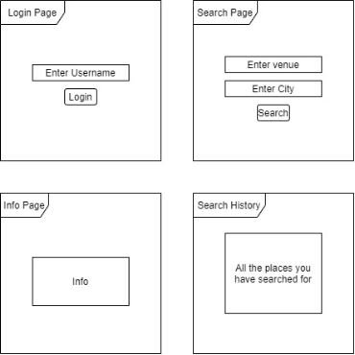

### Navigation

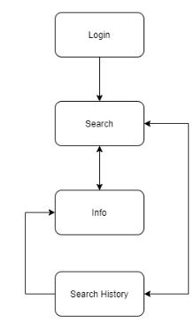

### Backend Flow

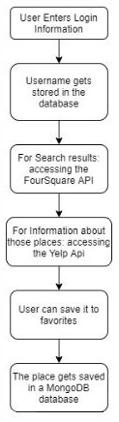

## UI Screenshots

Login page

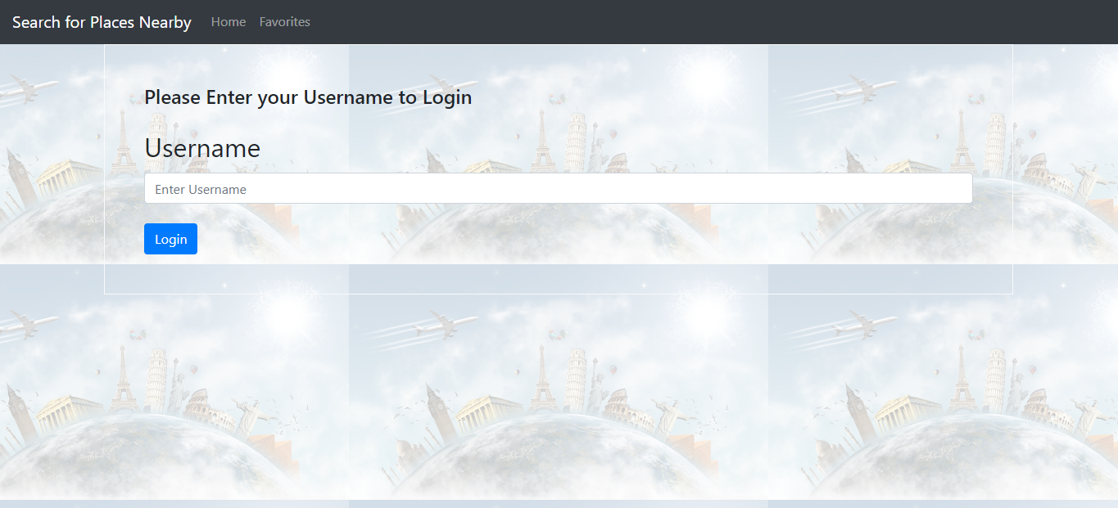

Initial Homepage

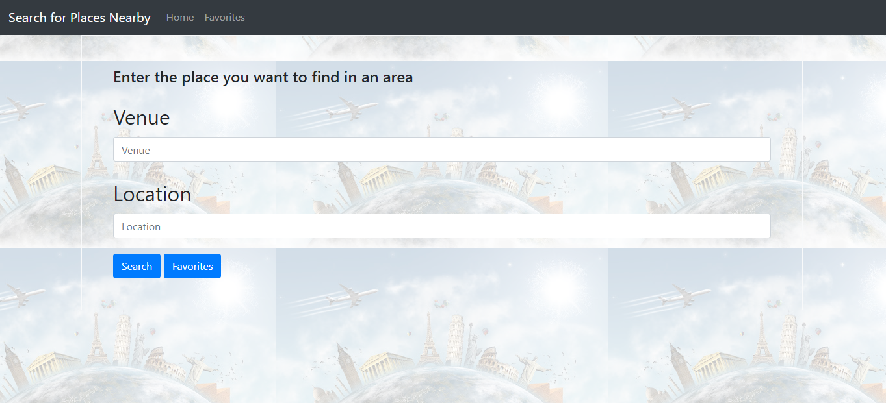

Homepage Search Results (Zoomed out to show results)

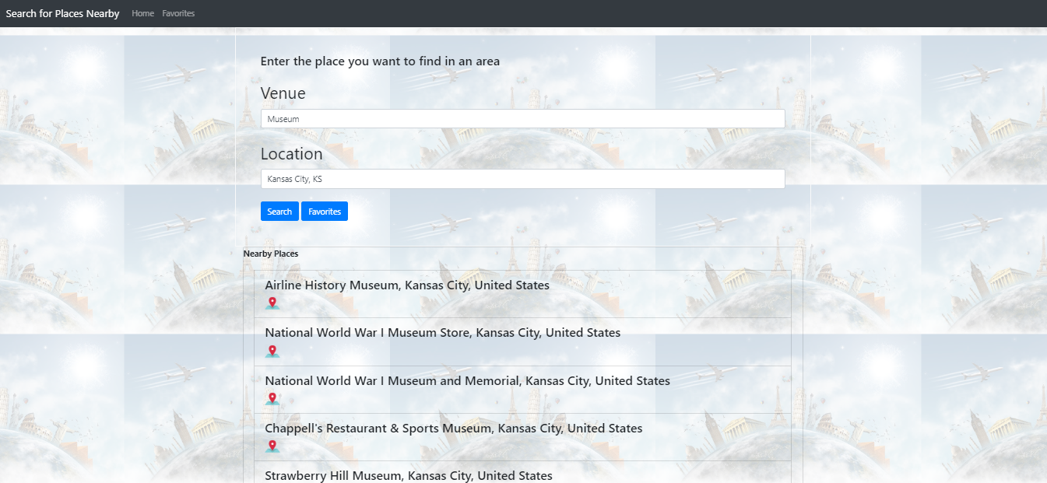

Place Information Page

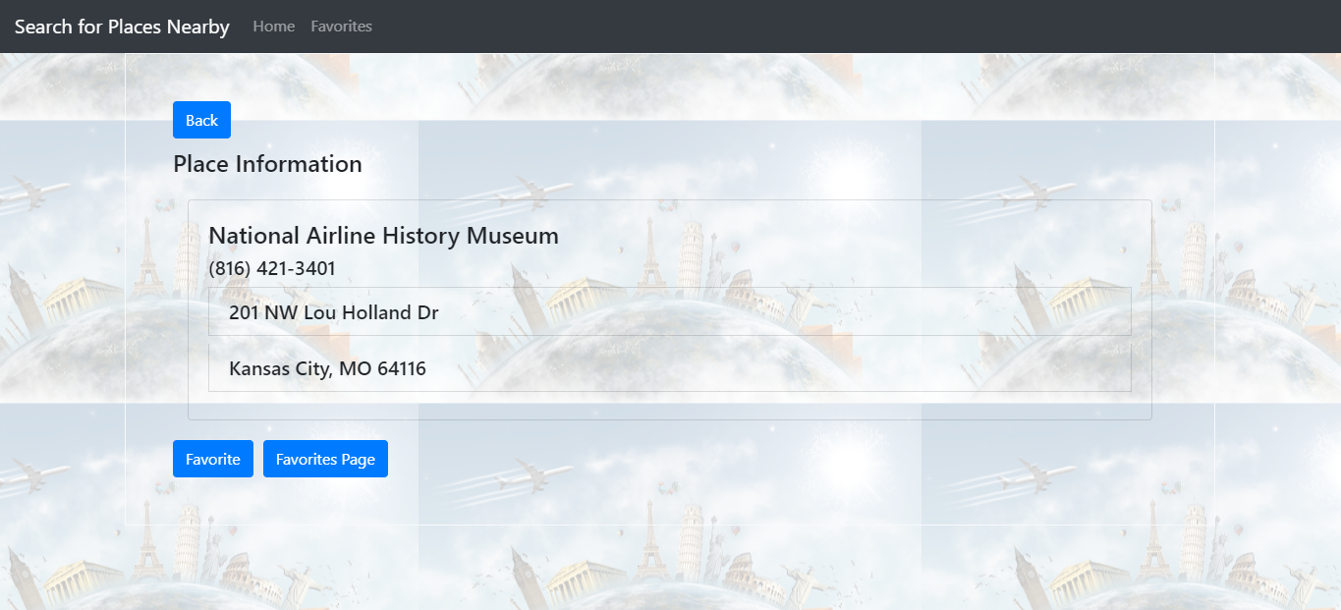

Favorites Page

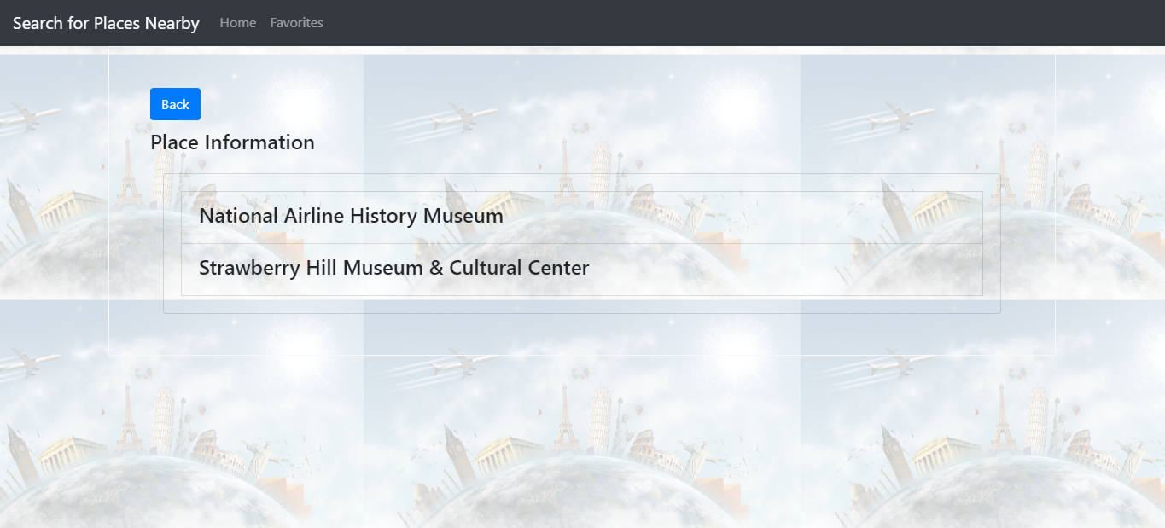

MongoDB

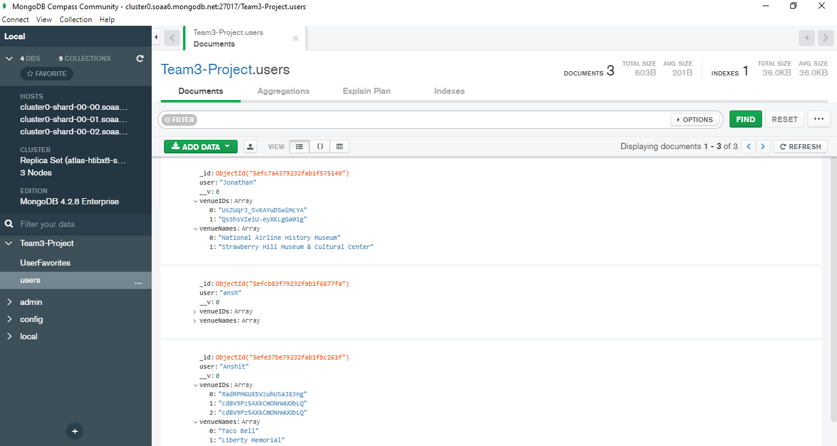

## GitHub link

<https://github.com/JAWolfe04/Web_Mobile_Summer_2020_Team_3_Projects/>

## Issues

We had considered using Google Places API to retrieve the locations of the search query and Google Knowledge Graph API to gather information about the location. We used FourSquare Places API instead of Google Places API because FourSquare Places API is free and does not require a credit card to be used to use the API. Google Knowledge Graph API was not working the way we expected, thus we used the Yelp API to retrieve information about a location. The Yelp API is still limited as some locations are not in the Yelp database. Another issue developed from calling the Yelp API from a localhost and returning a CORS error that could only be resolved by using a CORS proxy, which we used <https://cors-anywhere.herokuapp.com/>.

## Future Work

Some features that can be added:

* Editing and updating of the favorites
* Having a search history along with favorites

## References

1. <https://developer.foursquare.com/docs/api-reference/venues/search/>
2. <https://www.yelp.com/developers/documentation/v3/business_match>
3. <https://www.yelp.com/developers/documentation/v3/business>